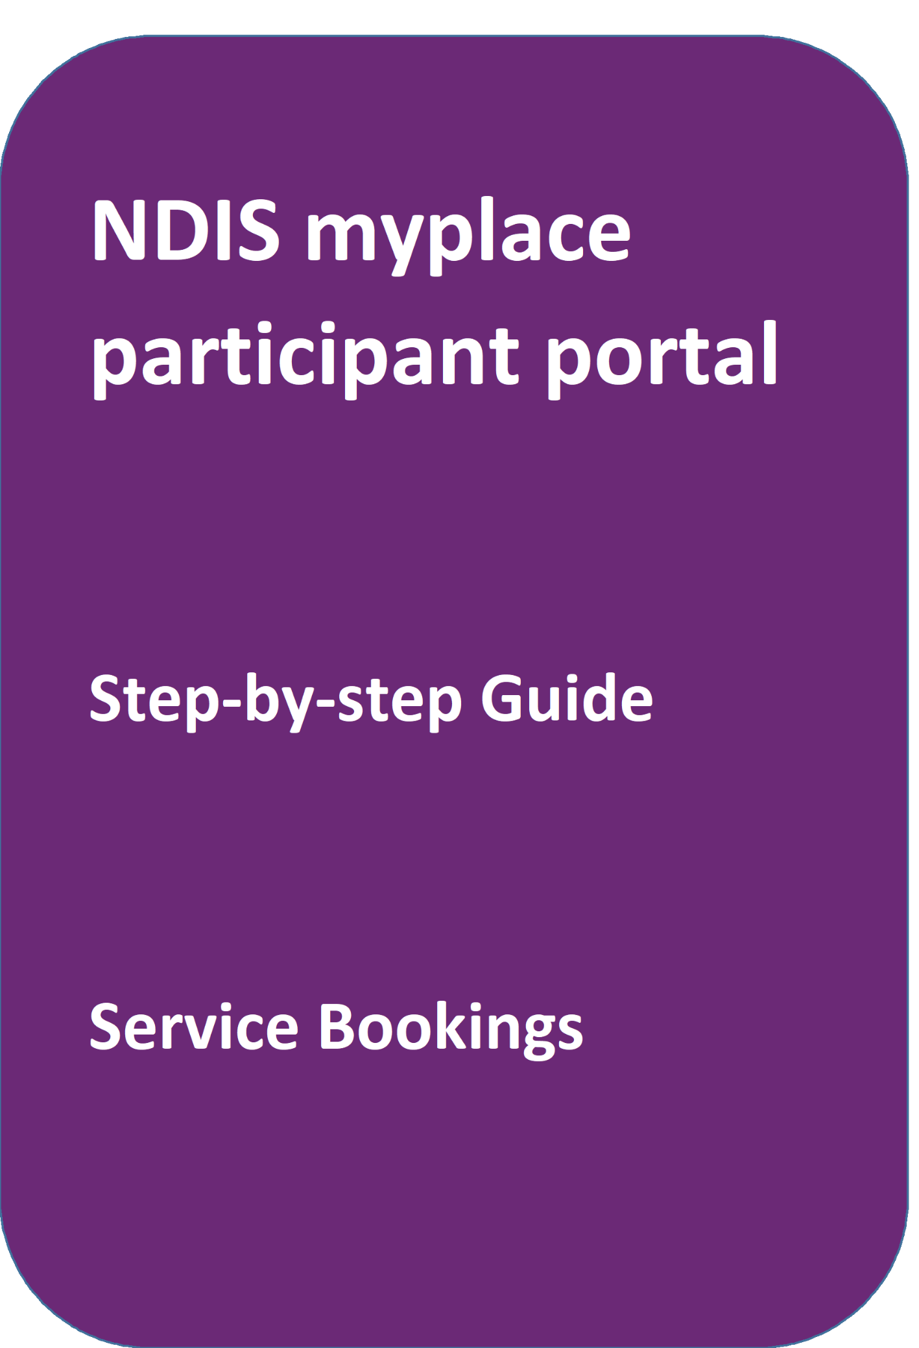
portal
May 2024

Table of Contents
Table of Contents 2
Changes from the last version 3
My Service Booking 3
Service bookings with different funds management 3
Add My Service Booking 4
View existing bookings 14
Refine search 15
Edit a service booking 18
Change the dollar values in a Service Booking 18
End Service Booking 22

Changes from the last version
The following updates have been made to the last published version of the myplace portal step-by-step guide:
- General updates.

My Service Booking
Service bookings are used to set aside funding for a NDIS registered provider for a support or service they will deliver. The provider can then claim payments against the service booking. A service booking will show the type of support to be provided, the length of time it is needed, and sets aside funding to pay for the support or service. Service bookings can be made by you, your nominee or an NDIS registered provider (with your consent). Self-managing supports do not have a service booking. If your plan is 100% self-managed, you do not need to go over this section.

Note: A service booking is different to a service agreement. A service agreement is an agreement between a participant and a provider. All participants should have service agreements with their providers, as the agreement sets out the expectations for the service to be delivered. Service agreements will not appear in the portal.

Service bookings with different funds management
If your NDIS funds are self-managed
You don’t use service bookings because you pay your providers directly.

If your NDIS funds are plan-managed
Your Plan Manager will make one service booking, which allows the Plan Manager to claim payment from the NDIS for all services and supports in your plan. In this case, both NDIS registered and unregistered providers can be included in the service booking.

If your NDIS funds are Agency-managed
You will need to give your NDIS registered service providers your NDIS number and the relevant support areas you have been funded for, so your provider/s can create the service booking on your behalf and receive payment.

- Select the My Service Booking tile from the home page.

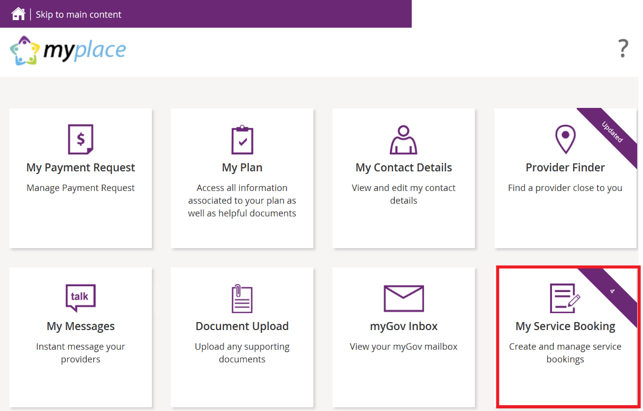

The Service Booking page displays. You have two tiles:
- Add My Service Booking
- View My Service Booking

Add My Service Booking

You only add service bookings for supports that are Agency-managed. Your provider may have already created a service booking on your behalf, so check with them first.

1. Select the Add My Service Booking tile.
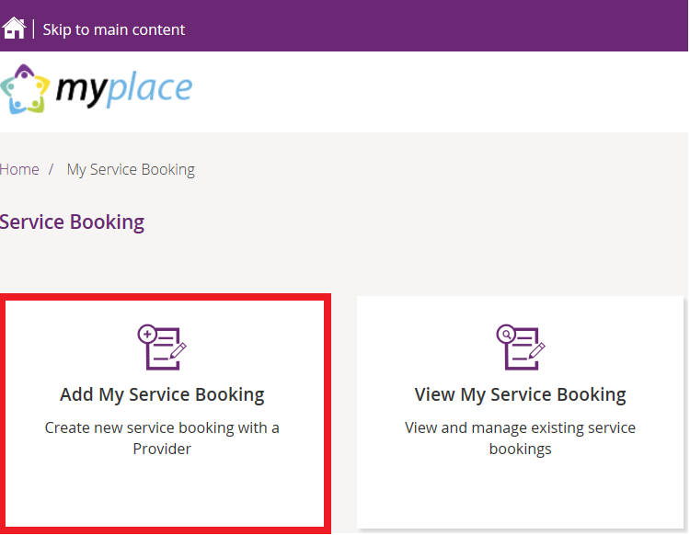

2. Select the Find the Provider button to choose your provider.

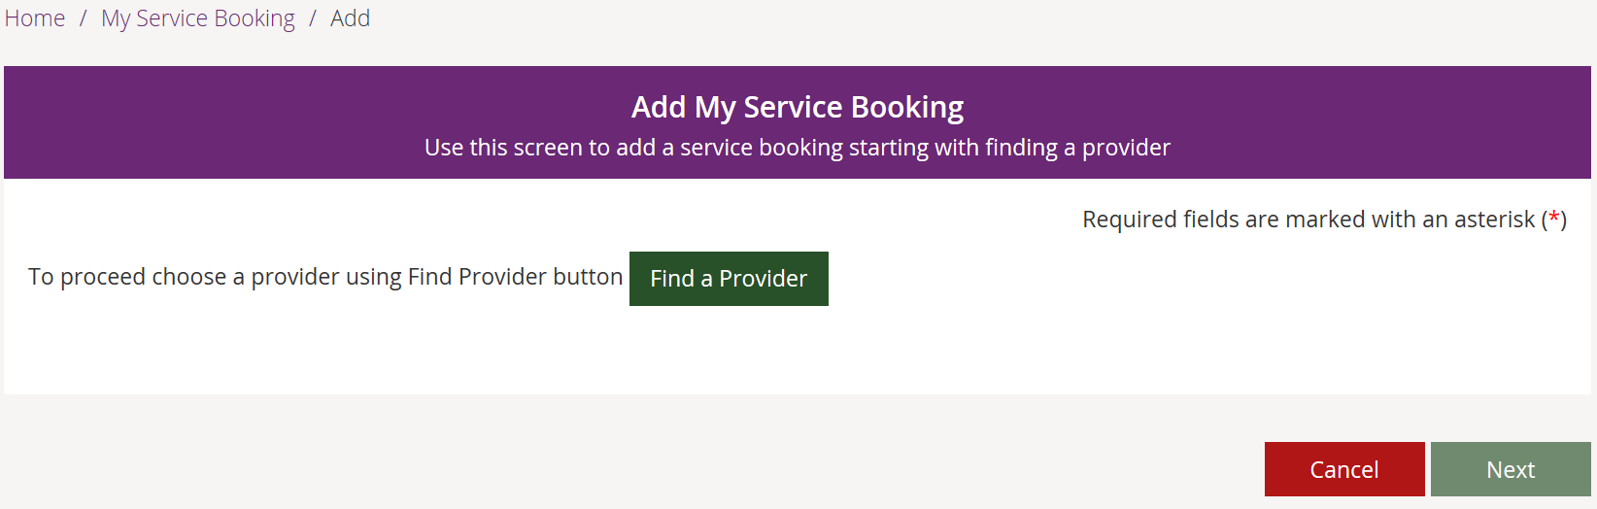

You are moved to the Provider Finder section of the portal.

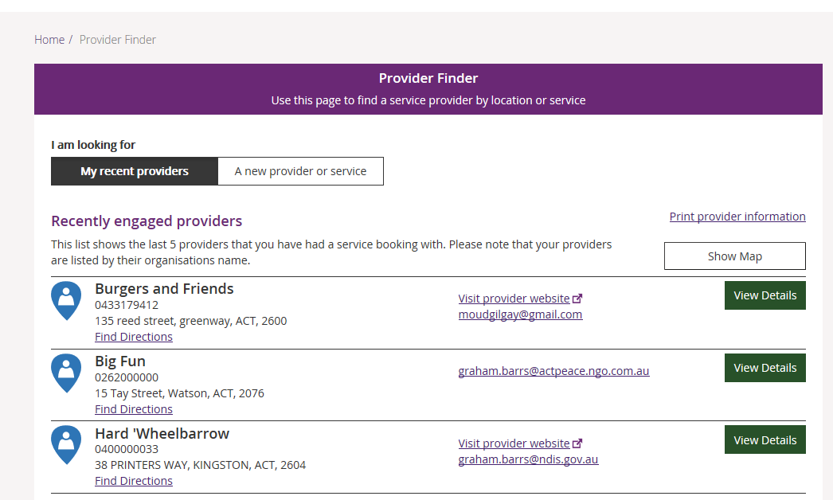

3. Once you have found the provider, select View Details of the provider and then click
the Create Service Booking button. If you need help, go to Part 4 – Provider Finder
and documents guide.

You are returned to the Add My Service Booking section.

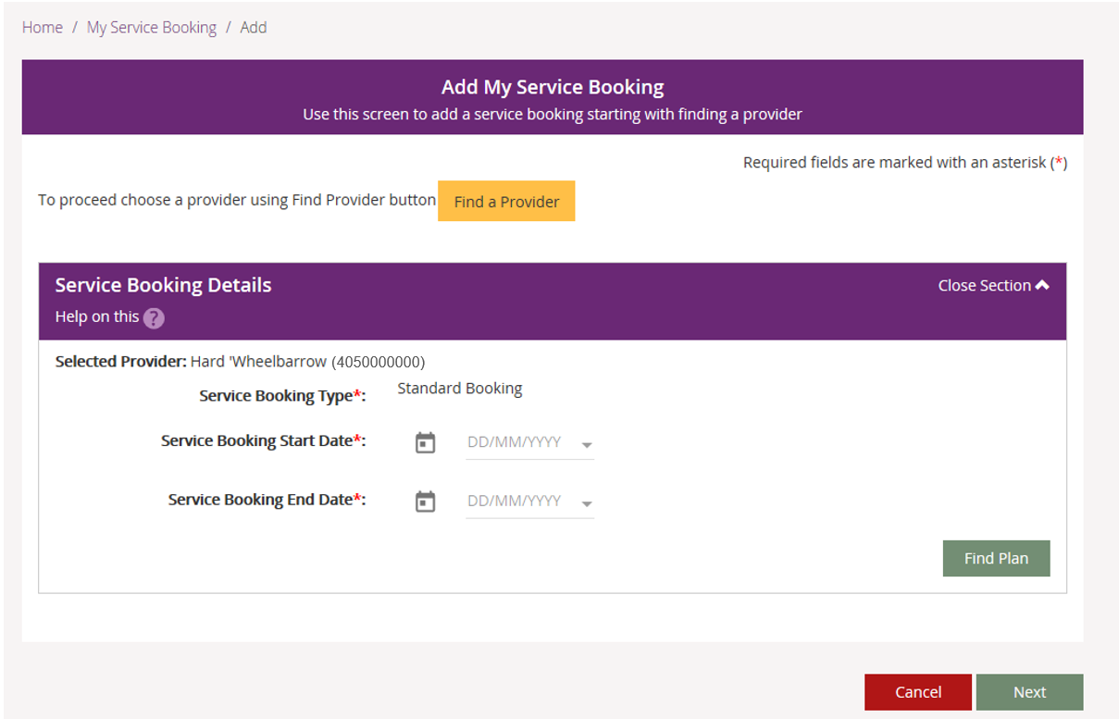

4. Enter the Start Date and End Date of the service booking.

Note: these dates must be within the start and end dates of the current plan.
5. Select the Find Plan button.

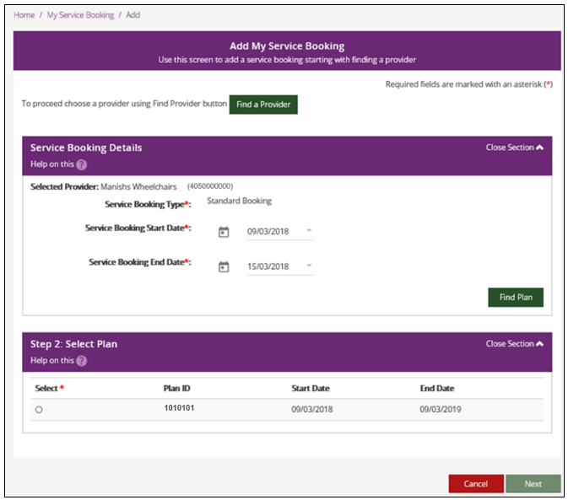

6. Step 2: Select Plan displays. Select the radio button next to the plan.

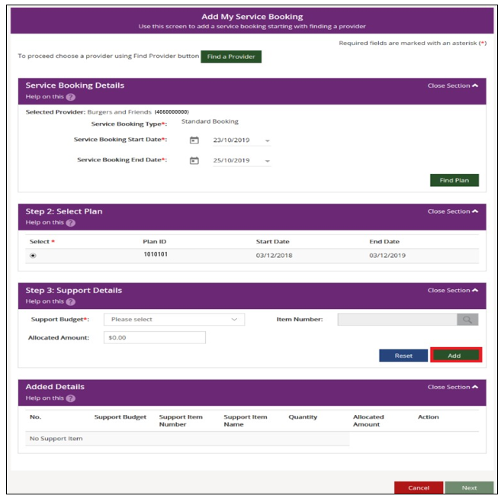

Step 3: Support Details and Added Details display.
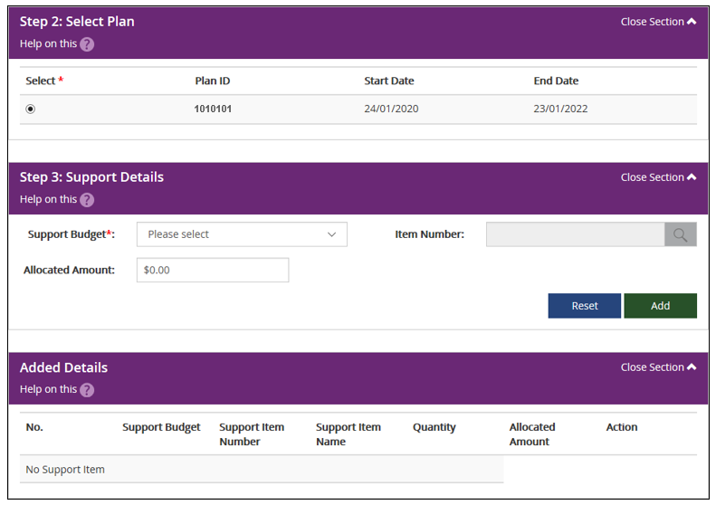

7. The Support Budget displays the categories of funded supports in your NDIS Plan.
Select the category from the drop-down list and enter the Allocated Amount. Once
completed, click the Add button.
Generally, you are not required to select an Item Number (this is a specific item within the support category) unless discussed with your provider. If you do specify the item, the Allocated Amount is the agreed rate for that item. You will then enter the quantity of services needed.
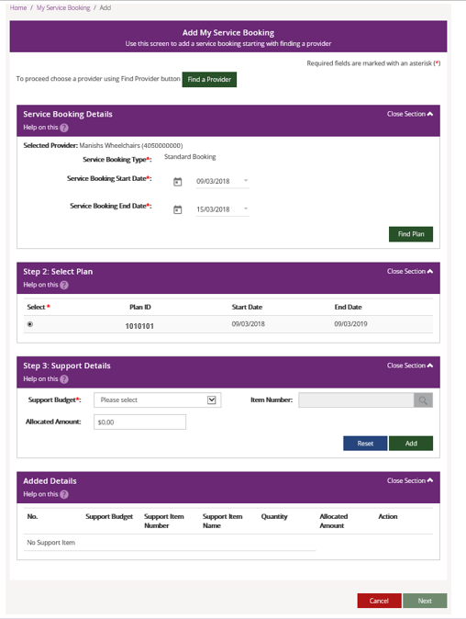
8. To add more supports under the same provider, return to Step 7.
9. If you need to make changes, click the Edit link to amend a support, or the Remove
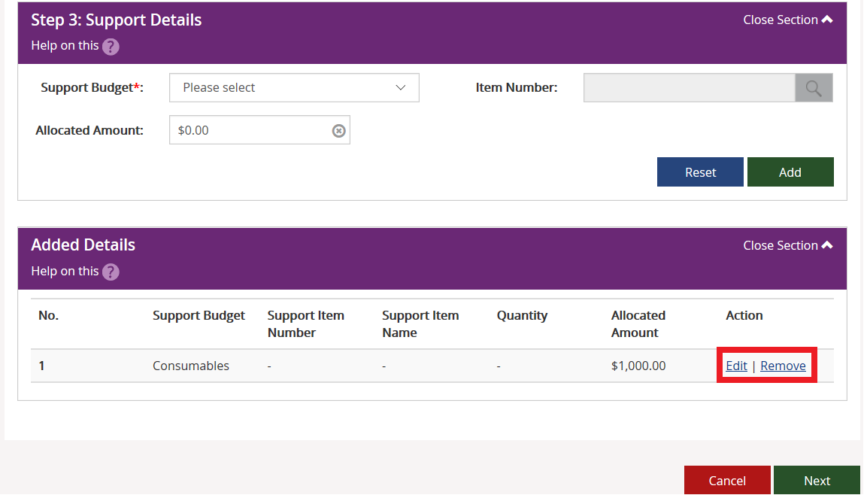
link to delete a support.

10. Once all supports are added, click Next.

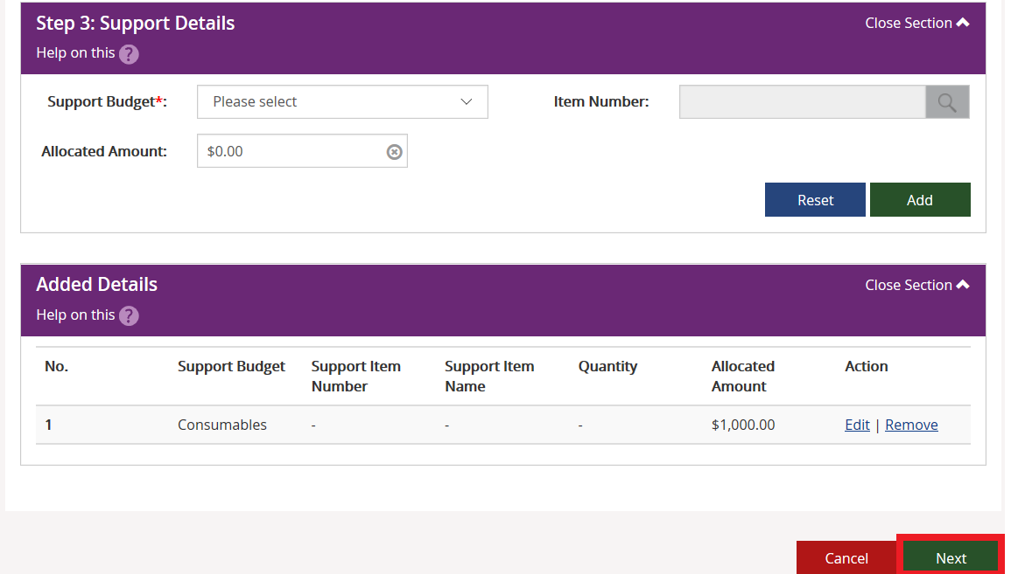
The Review screen displays.
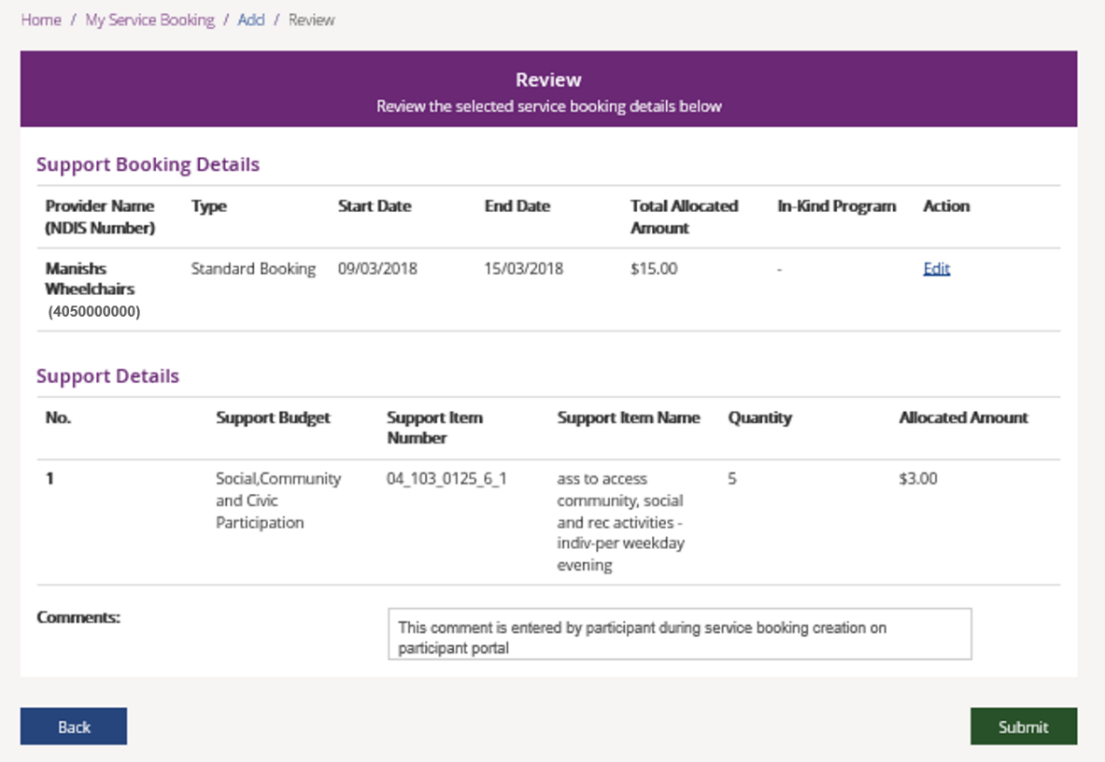

11. Notes may be added in the comments section. The provider will see these
comments.
12. Select the Submit button to create the service booking.
A service booking confirmation message displays.
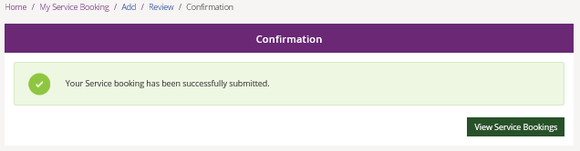

Select View Service Bookings to see the details of any of your service bookings.

Note: The status of the service booking you have created is Awaiting Provider Review.
When the provider accepts the booking, the status will show as Active. If your provider
rejects the booking, the service booking status will show as Rejected. The reason for
rejection can be seen in the View Service Booking Details screen.

View existing bookings

1. Select the View My Service Booking tile on the Service Booking page.
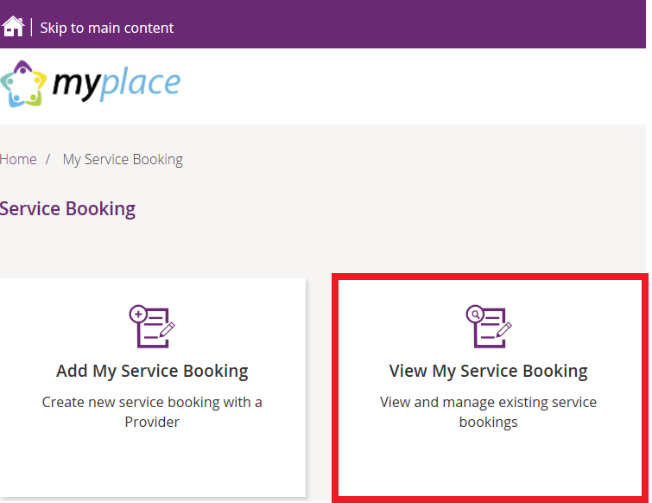

Your service bookings display.
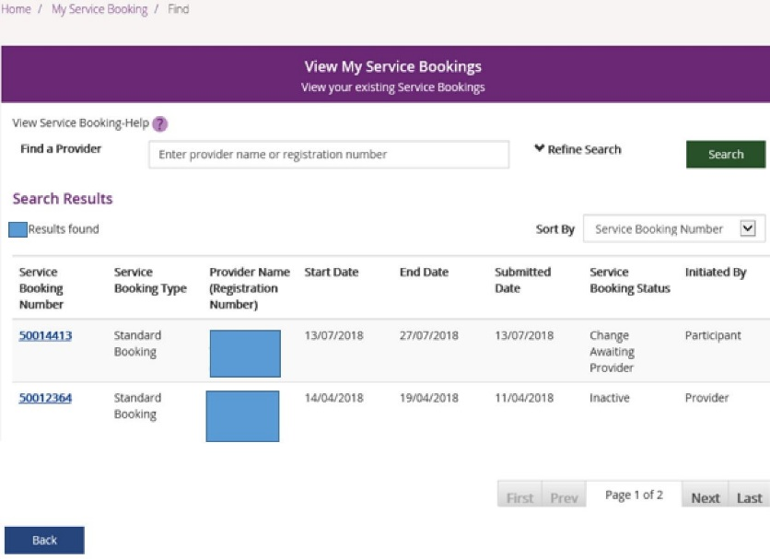

Refine search
- You can search by a provider or to expand the search criteria, click the Refine Search button.

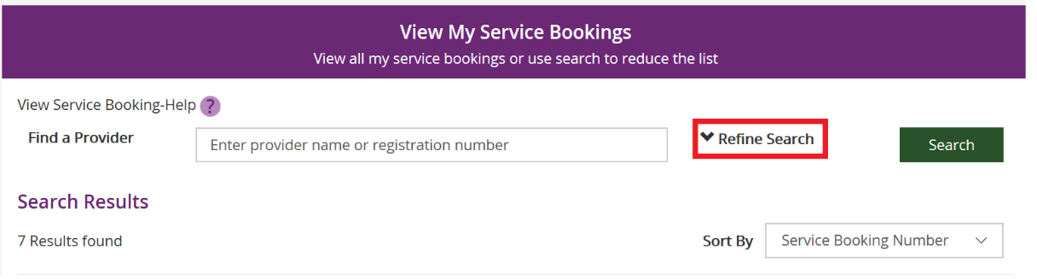

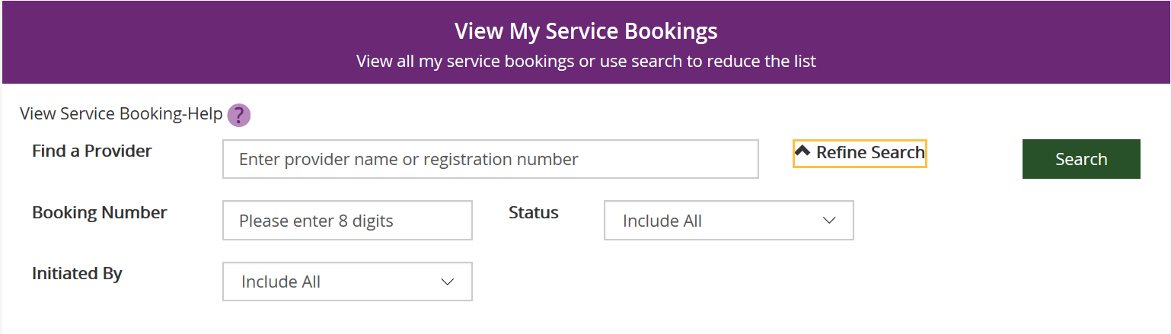

You can search by:
- Booking Number – refers to the 8-digit service booking number.
- Status – refers to the service booking status. For example: active/inactive, awaiting review, awaiting provider review, change awaiting provider, review change or rejected.
- Initiated by –who initiated the booking. For example: all, participant, provider or staff.
2. Once you have entered your search criteria, select Search.
3. You can sort your search results by clicking the Sort By drop down field. The options
are:
- Initiated by
- Service Booking Number
- Service Booking Start Date
- Service Booking End date
- Submitted Date
- Service Booking Status

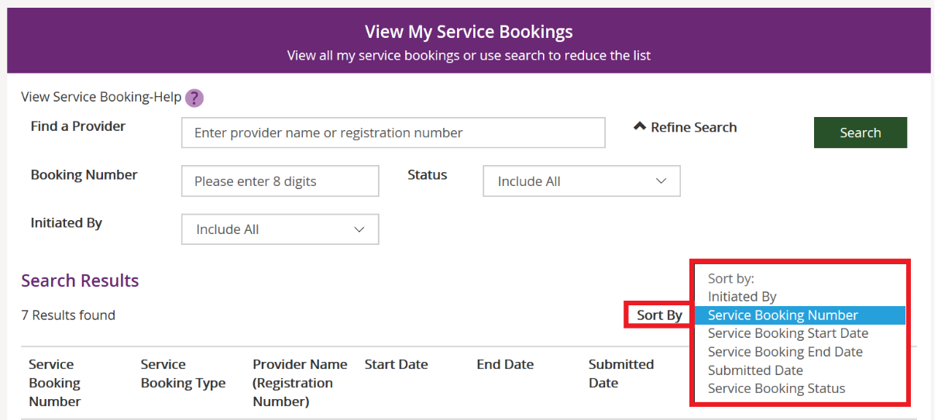

4. To view details of a service booking, click on the Service Booking Number.

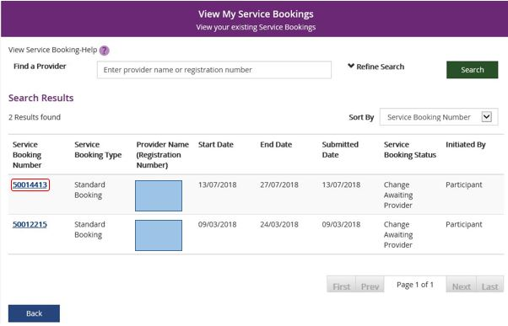

5. If the status is ‘awaiting provider review’ you can delete the service booking by selecting
Delete. Once a service booking has been accepted by the provider it cannot be deleted.
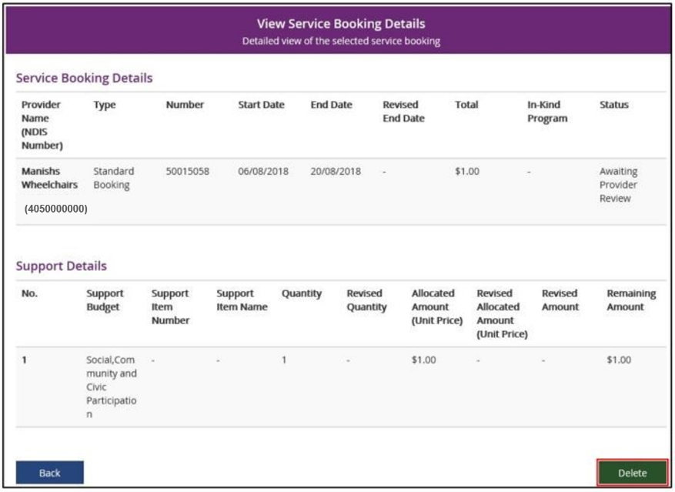

6. Once you select Delete, the following warning message displays.

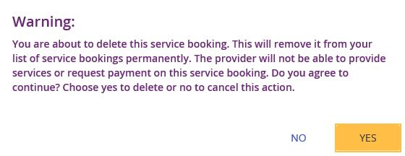

7. If you select Yes, you will receive the following message confirming the service
booking has been deleted.

You are returned to the View My Service Bookings page.

Edit a service booking
You can change or end a service booking (with the status Active) if it was created by yourself, your provider or by the NDIA.

Change the dollar values in a Service Booking
- Click the View My Service Bookings tile on the Service Bookings page.
- Click the Service Booking Number of the booking you wish to edit.
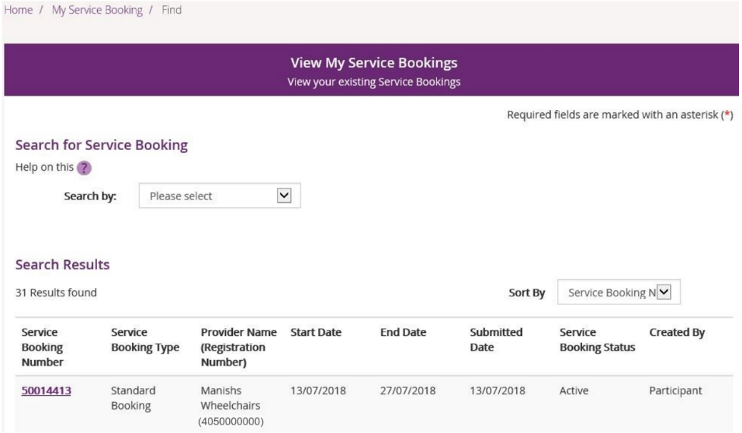
3. Click the Request Update Allocation button in the bottom right-hand corner of the
window.
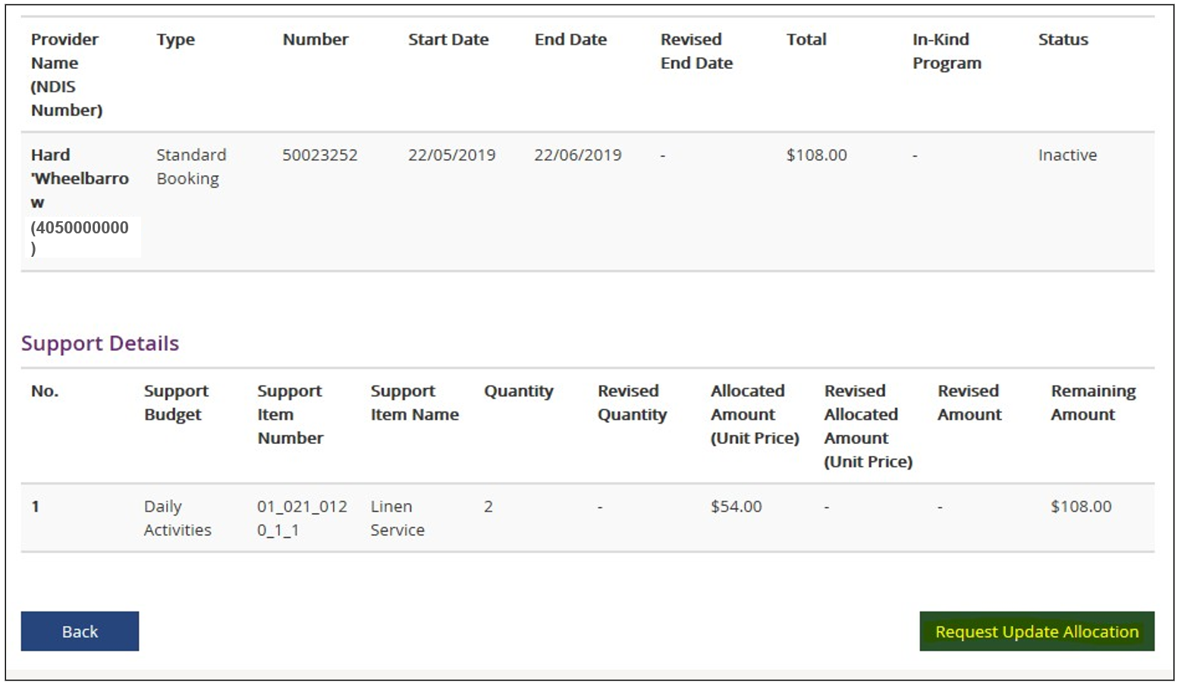

The Request Update Allocation page will display.

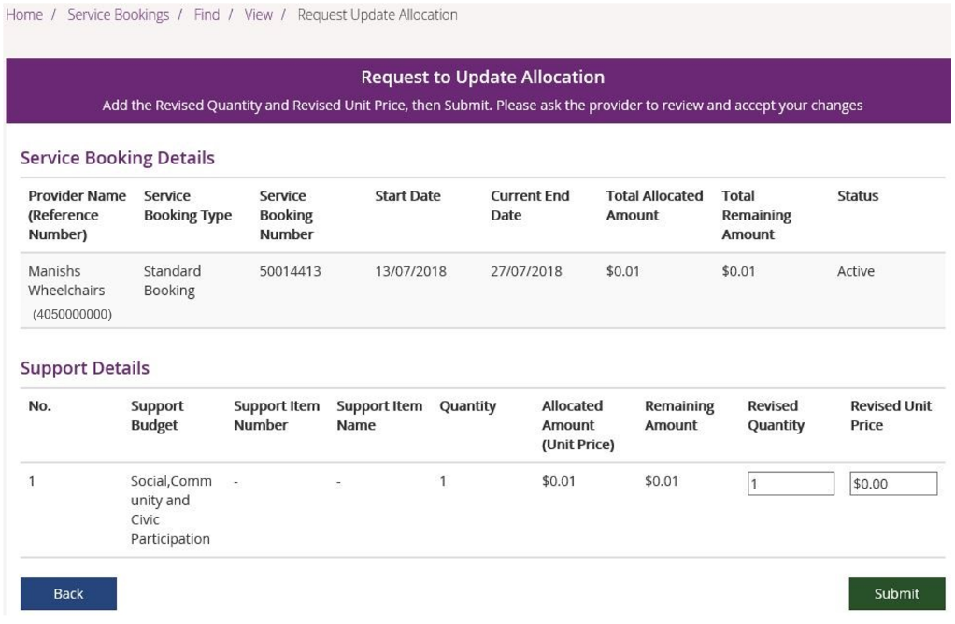

4. Enter the Revised Quantity and Revised Unit Price and then select Submit.

A message displays at the top of the screen stating the details have been updated successfully.
5. Click the Back button to return to the View My Service Bookings page.

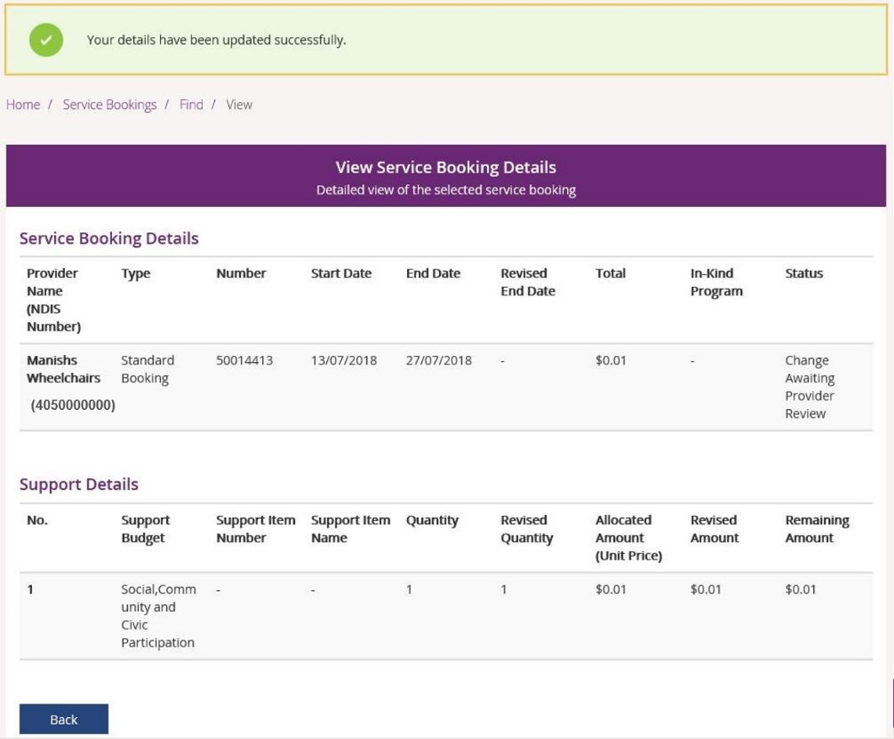

The status of the service booking will change to Change Awaiting Provider Review. This means the provider can accept or reject the changes you have made. If the provider accepts the changes, the status returns to Active.

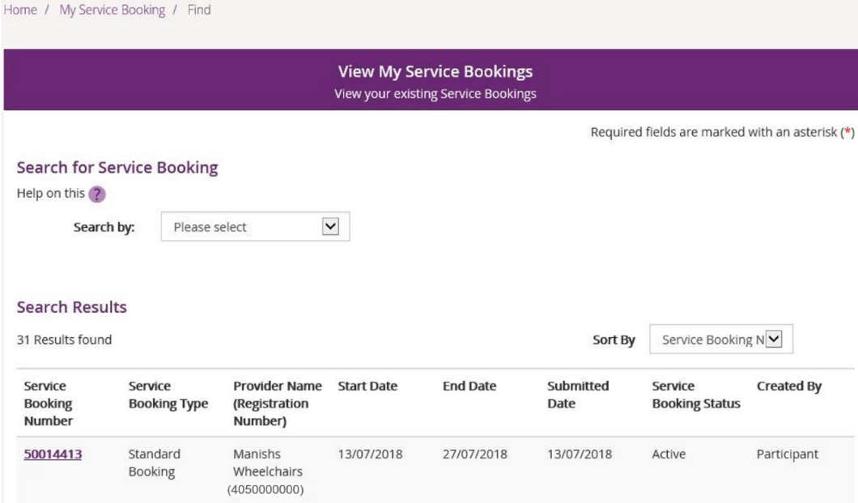

If your NDIS provider makes a change to your service booking, you will receive the following SMS notification:
“Your NDIS Provider has updated your service booking (number). Please review the change and discuss with your provider if necessary. Do not reply by SMS.”

End Service Booking
You can request to end a service booking with an active status that was created by the NDIA, your provider or yourself. The service booking will not be ended until your service provider accepts your request to end the service booking.

- Select View My Service Bookings and click the Service Booking Number of the booking you wish to end.
- Select Request End Date Change to end the service booking.

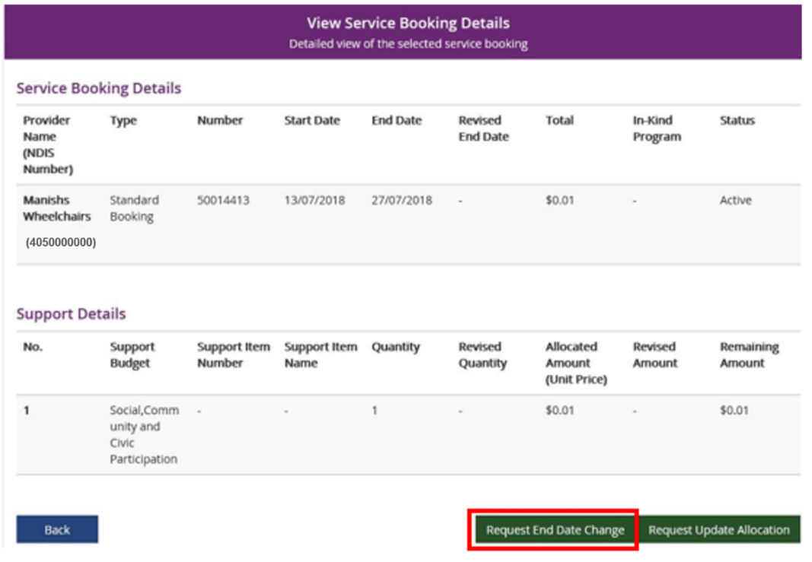

- Enter the Service Booking End Date and select a Reason for Change from the drop-down list.

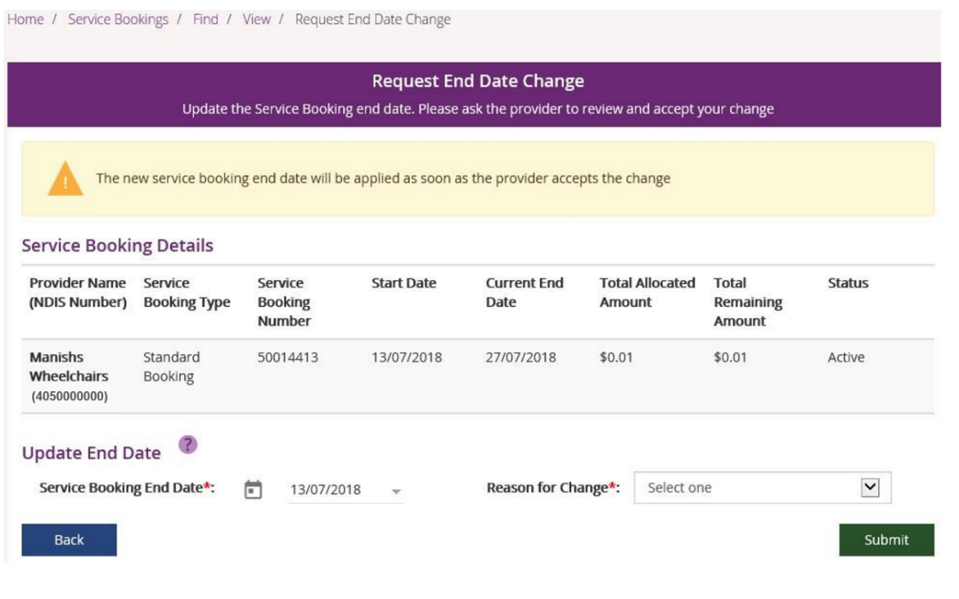

- Click the Submit button in the bottom right hand corner of the window.
- An alert message displays confirming you want to continue. If you want to ending the service booking click Yes. If not, click No.
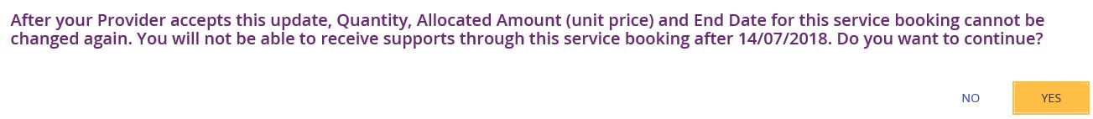

You will receive a message at the top of the screen confirming the details have now been successfully updated.

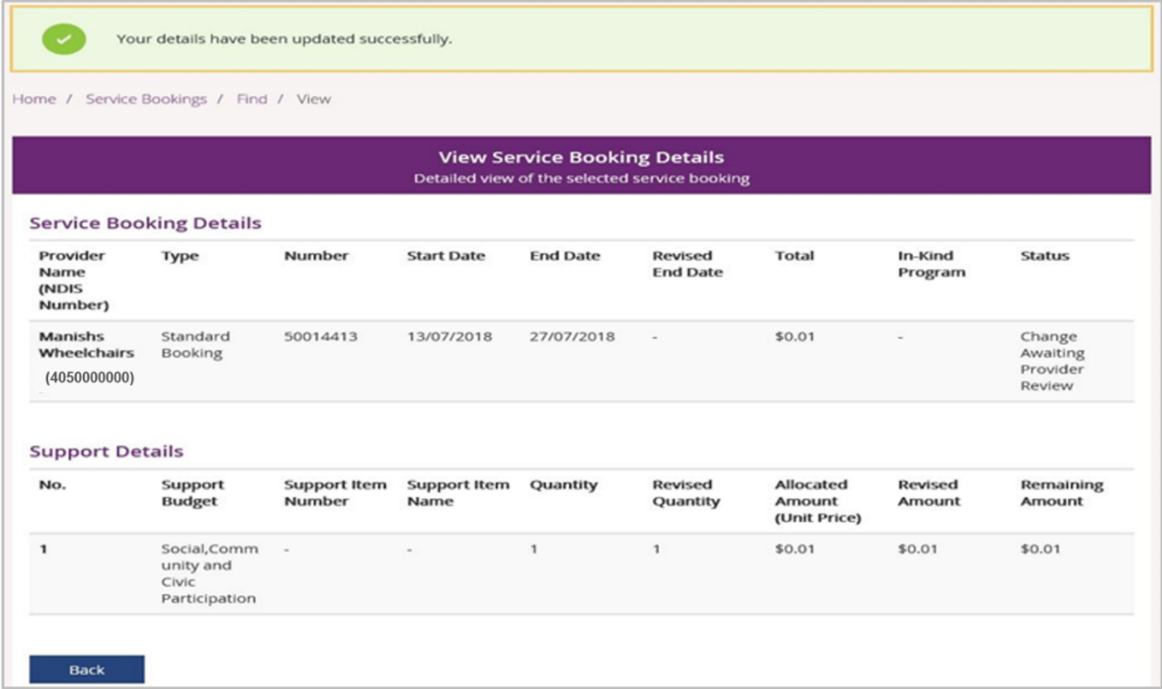

The status of the service booking will change to Change Awaiting Provider Review. This means the provider can accept or reject the changes you have made. When the service booking ends the status will show as Inactive. If the provider rejects your change for whatever reason, the status will show as Active and you will need to contact the provider.

